CHAPTER 3: RESEARCH METHODOLOGY

3.1 Introduction
This chapter outlines the methodology employed in developing the Plant Disease Classifier system.
It describes the research framework, methods used for data collection and analysis, system design diagrams,
and the tools applied in the implementation process. The main objective of the methodology is to ensure that
the developed model is efficient, accurate, and user-friendly for plant disease detection.

3.2 Research Method
This research uses an applied experimental design with a secondary dataset approach.
The dataset was obtained from publicly available sources containing labeled plant leaf images.
The MobileNetV2 convolutional neural network architecture was trained and optimized to classify diseases based on leaf features.

3.2.1 Requirement Gathering
The requirement gathering process identified key features such as image input, disease prediction, and result visualization.
Both functional and non-functional requirements were defined to ensure system reliability and performance.

3.3 Data Flow Diagrams (DFD)
Data Flow Diagrams are used to visually represent the flow of data within the system.
They help understand how input data (leaf images) is processed to produce disease classification outputs.

3.3.1 DFD Level 0
The Level 0 DFD provides a high-level view of the system’s main components, showing how the user interacts
with the classifier and how data flows between processes.
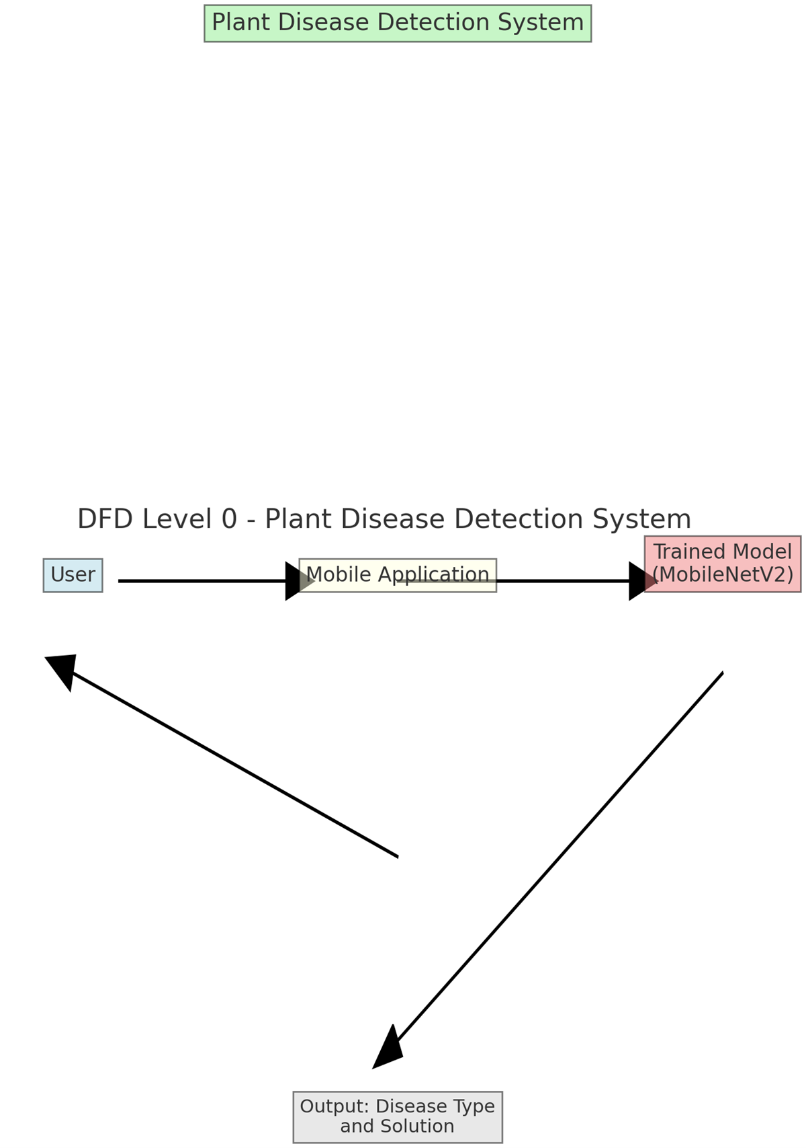

3.3.2 DFD Level 1
The Level 1 DFD presents a more detailed view, showing subprocesses such as image preprocessing,
feature extraction, and classification. It helps in understanding how raw data is transformed into
meaningful disease predictions.
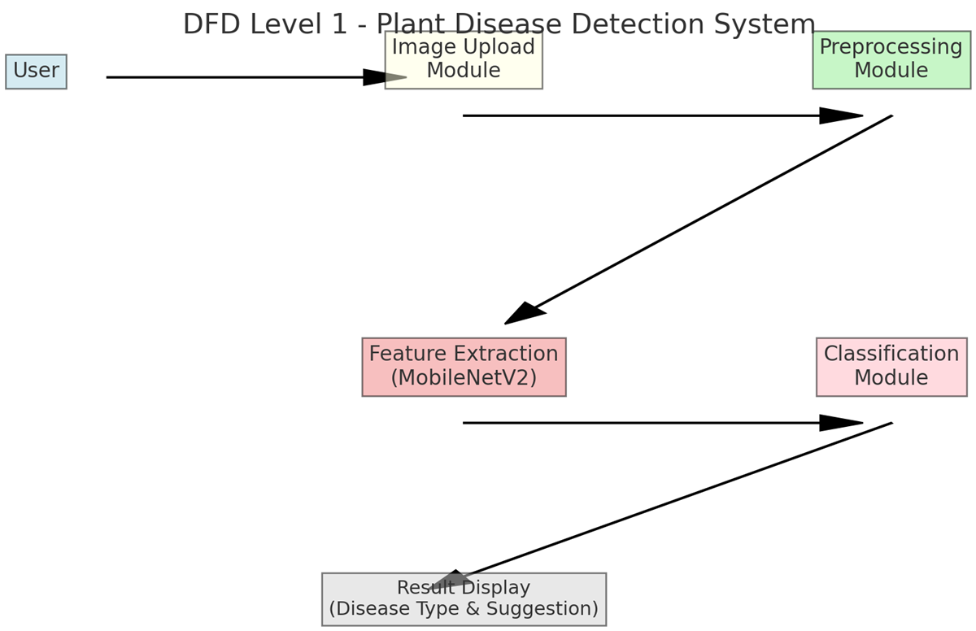

3.4 Use Case Diagram
The Use Case Diagram illustrates interactions between users and the system.
It identifies the roles of different actors (User and Admin) and the operations they perform within the system.
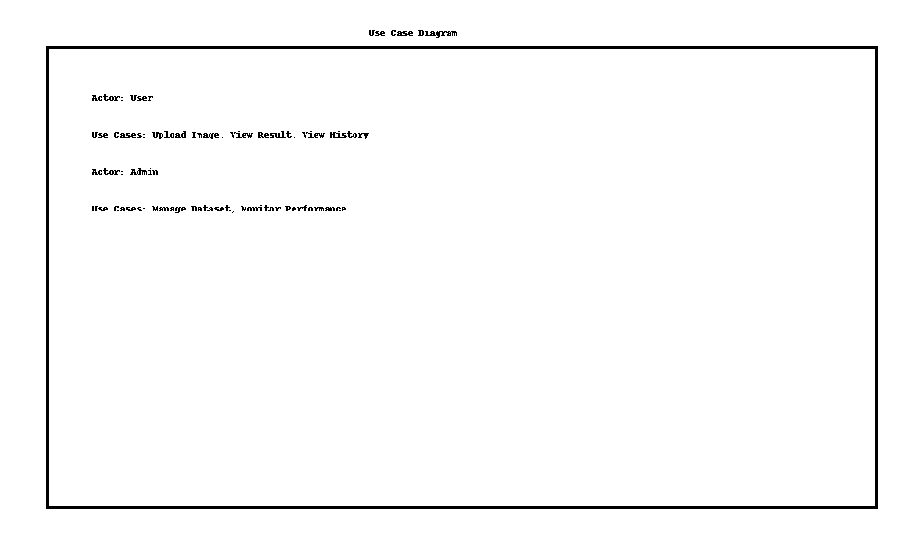

3.5 Sequence Diagram
The Sequence Diagram outlines the sequence of operations during the disease detection process.
It demonstrates how user inputs trigger backend processes leading to the generation of results.
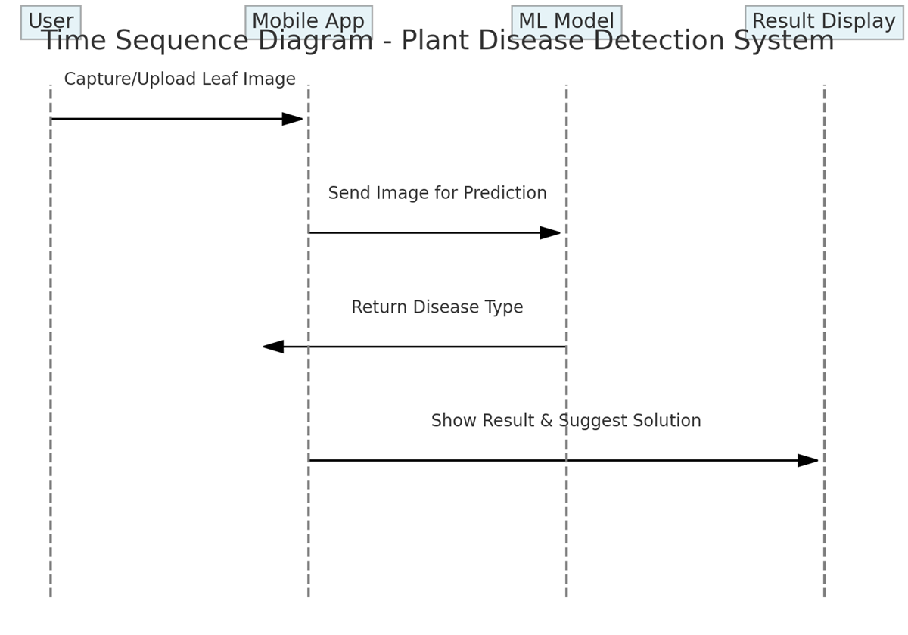

3.6 Software Development Model
The Agile methodology was selected due to its iterative and flexible nature.
The project was divided into sprints focusing on dataset processing, model training, and user interface development.
This approach enabled continuous testing and refinement.

3.7 Data Analysis
The dataset was analyzed for class distribution, image quality, and balance.
Preprocessing techniques such as normalization, resizing, and augmentation were applied.
The model’s accuracy, precision, and recall were evaluated to ensure optimal classification performance.

3.8 Tools and Technologies
- Programming Language: Python
- Libraries: TensorFlow, Keras, OpenCV
- Architecture: MobileNetV2
- Platform: Android (for deployment)
- IDE: Jupyter Notebook, Android Studio
- Dataset: Secondary dataset (PlantVillage)

3.9 Summary
This chapter presented the research methodology used for the Plant Disease Classifier project.
It covered data analysis, design models, and development techniques.
The following chapter discusses the implementation and testing of the proposed system.

